Activity 4.3: Savings
Here is the start of a program that asks the user how much money they have saved and how much money they have just spent. It then works out how much money they have left. For example:
- Money saved = £15
- Money spent = £10
- Money left = £15 - £10 = £5
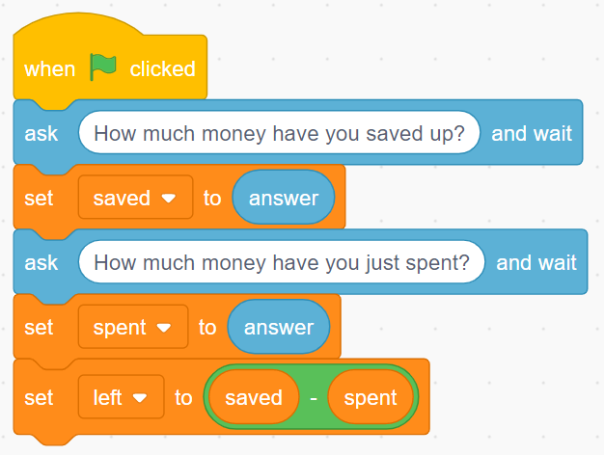
Create these blocks and then complete the program by adding more blocks so that the program:
- checks to see if the amount of money left is more than 0
- if it is, the cat should say You still have money left in your savings
- if it isn’t, the cat should say You have spent more money than you have in your savings.
Don’t forget to screenshot your blocks and paste the screenshot into your evidence document.

Extension activity 1
Improve your program so that, if there is money left, the cat tells the user how much money they have left. For example:
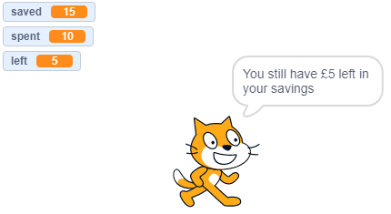

Extension activity 2
Improve your program further so that, if the user has spent more than they have saved, the cat says how much they have overspent by. For example:
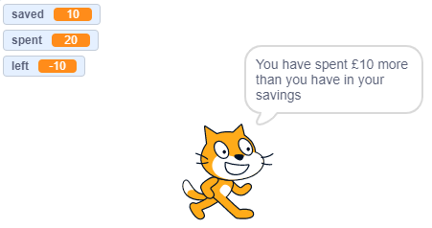

There are lots of ways to do this, but you can use a block that completes a mathematical function called ‘abs’ (‘abs’ stands for ‘absolute’). This will remove any negative sign from a number. This block can be found in the operator’s category.
Remember to screenshot your blocks and paste the screenshot into your evidence document.

